Jugo

Project: Jugo AI Tool IBCS Complaint
Researcher: Ali Albukhaiti, Ayoub
Stakeholders:
Mohamed Abouyakob
m.abouyakob@jugo.nl
Christian van Bracht
c.v.bracht@jugo.nl
Project Coach
Senne
Date: 2026

Jugo – Domain Analysis

Problem Context & Summary
Jugo is a company specializing in consulting on IBCS compliance in dashboards. IBCS (International Business Communication Standards) is an international framework used by businesses to create standardized dashboards, ensuring consistent and unified business language worldwide.
One of the main challenges Jugo faces is that analyzing IBCS compliance manually is very time-consuming and labor-intensive. This process requires experts to carefully review dashboards and check whether they follow all IBCS rules.
To solve this problem, Jugo envisions an AI-based tool that can speed up the process of checking IBCS compliance. The idea is that data analysts can simply upload dashboard images, after which an AI model scans them for compliance and provides feedback on possible improvements.
Because IBCS is a very extensive framework, building a model that covers all rules at once would be too complex. Therefore, Jugo asked our group to focus first on a single rule: the unification of scenarios.
This rule ensures that dashboards use consistent visual representations for different scenarios. The required standards are:
- Actual (AC): Dark solid color
- Previous Year (PY): Solid lighter shade of Actual
- Plan (PL): Outlined area (not filled)
- Forecast (FC): Outlined area filled with a hatched pattern
- Appropriate abbreviations for scenarios
Further details are defined in the requirements.

Cost of Mistakes
The model we are building is a proof of concept. Due to limited availability of IBCS-compliant dashboards, we expect to train the model on approximately 300–500 images. Based on research, this should result in an estimated accuracy of around 60%, which is sufficient to demonstrate that the model can structurally distinguish between compliant and non-compliant dashboards.
Improving accuracy will mainly depend on collecting more data rather than significantly changing the model.
The cost of mistakes is relatively low. The main risk is incorrect classification:
- If a non-compliant dashboard is classified as compliant, it may be used in business settings.
- Since it does not follow IBCS standards, it could be less effective or misinterpreted by decision-makers.
- This may lead to suboptimal or incorrect business decisions.
However, the dashboards still contain the same data, only presented incorrectly, which limits the overall impact of errors.

Data Requirements
- Define Objectives: The project objective is to make an AI tool that can classify and provide feedback for data analist. If uploaded dashboards are compliant or non-compliant according to the IBCS framework.

- Data Characteristics: For the project we should have images of compliant and non-compliant IBCS dashboards. Since this is gonna be supervised learning, each image should be labeled as compliant or non-compliant for the model to learn. Additionally for the model to provide feedback if the framework rules are followed or not. The data should contain a label for each rule with at least a binary value if it is followed or not. And to provide feedback it should contain written comments, explaining why the rule is followed or not. For the model to learn and provide feedback.

As previously mentioned to train the model there should be at least 300-500 images divided 50/50 in compliant and non-compliant IBCS dashboards. To hopefully obtain a 60% accuracy.

- Data Sources: The most prominent source for gathering data will be scraping images for example from google images. As well as an inital set of images provided by the stakeholder of 27 IBCS compliant dashboards.

- Data Legality and Ethics:
- Use only publicly available data or data with appropriate licenses.
- Respect the terms of use of the data sources.

- Data Diversity: Based on a workshop provided by the stakeholders on IBCS compliance. IBCS is only a framework for businesses to create dashboards. However there is still some marginal room for businesses to create IBCS compliant dashboards in their own way. Therefore in the data we scrape we should make sure that data gets gathered from different sources to remove any possible bias. And make sure the model can properly classify any dashboard from any business.

- Version Control: Implement version control for your data. As you clean, preprocess, and augment data, maintaining a clear history helps ensure reproducibility.

- Iterative Process: Data requirements is an iterative process. Continuously evaluate and update your data sources as you gather feedback and insights from your model's performance.

Data Availability & Labeling Strategy
We will start with a small test dataset of 40 images:
- 20 compliant
- 20 non-compliant
If we want the model to provide feedback, we will need more detailed labeling. We identified several labeling approaches:
Compliant and Non-Compliant should always be labeled as: compliant is 1 and non-compliant is 0.

Option 1: Labels with Detailed Comments
Each image is labeled as compliant (0) or non-compliant (1), with additional comments per rule.
Example:
- Actual: different colors used
- Previous Year: different colors used
- Plan: incorrect representation
- Forecast: incorrect representation
- Missing or incorrect abbreviations (AC, PY, PL, FC)
This approach provides rich feedback but requires more effort.

Image | Compliant | Rule 1 (Actual Solid) | Rule 2 | Rule 3 | ...
IMG1 | 1 | Pattern is not Solid
IMG2 | 1 | Pattern Solid

Option 2: Rule-Based Binary Labels
Each rule is labeled separately as correct (0) or incorrect (1).
Complaint = 1
Non-Complaint = 0
Example:
Image | (Plan) | (Actual Solid) | Previous | Forecast | ...
IMG1 | 1 | 0 | 0 | 1
IMG2 | 1 | 1 | 1 | 1

- IMG1: Not complaint because Actual: has different colors used and Forecast: incorrect representation
- IMG2: Complaint because it follows IBCS Rules

We can also test whether adding short explanations (e.g., “Actual color should be solid dark”) improves performance.

Option 3: Simple Classification
Each image is only labeled as:
- Compliant (0)
- Non-compliant (1)
This is the simplest approach but does not support feedback generation.
Image | Compliant (1) /Non Compliant (0)
IMG1 | 1
IMG2 | 1

Option 4: Comparison with GenAI
We will compare our machine learning model with existing GenAI solutions.
If GenAI models perform better in classifying dashboards and providing feedback, it may be more beneficial for Jugo to:
- Use existing GenAI tools
- Or build a customized GenAI (LLM-based) environment
- Possibly run models locally for privacy reasons
Initial research shows that GenAI sometimes incorrectly classifies compliant dashboards as non-compliant. For example:
- A dashboard was marked non-compliant because Plan (PL) was shown as an open marker instead of an outlined area.

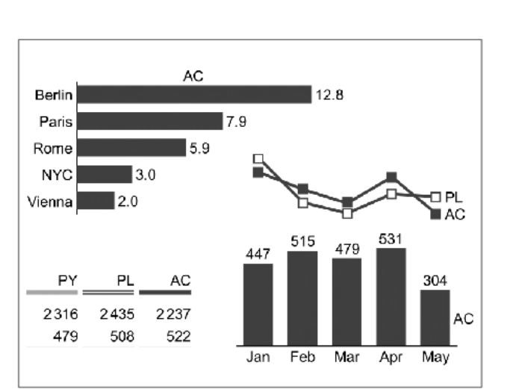

- Another dashboard was marked non-compliant because scenarios (AC, PY, PL, FC) were not explicitly labeled, even though context might have been present.

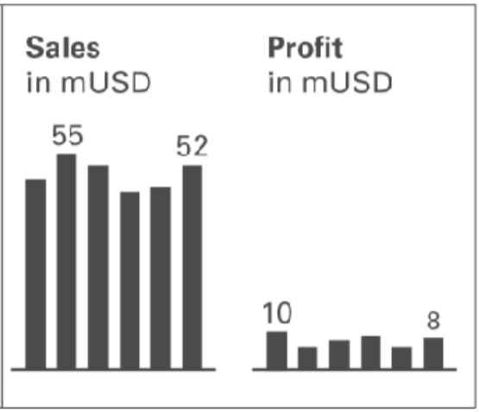

These findings suggest the need for further testing to determine whether a custom ML model performs better than existing GenAI.

Option 5: Training on Non-Compliant Dashboards
Another option we want to explore is training a model on only non-compliant dashboards. Each image we want to add written comments of feedback for each rule if it is or isn't compliant with IBCS. These rules will then be used for training the model as classes.
Then we want to train the model on those images and compare the results with the other options. We hope that since the model will get clear instructions on wrong images. It will be able to classify everything that isn't wrong would be right.

Analytical Approach
We researched the difference between multi-class and multi-label models.
- Multi-class models assign only one label per image
- Multi-label models allow multiple labels per image
Since dashboards can contain multiple mistakes at the same time, we must use a multi-label approach.
Because we want to differentiate between compliant and non-compliant IBCS dashboards, we should use a classification algorithm.
For image classification, we plan to use a Convolutional Neural Network (CNN) ResNet18 pre-trained model, as it is widely used for image-related tasks such as dashboard analysis.
We will test the different labeling strategies on a small dataset first. Based on the results, we will decide which approach to continue with.

Target Variable
In the previous chapters we discussed data and labeling options. During our research we couldn't find any existing datasets for our issue. This means we will have to create our own dataset. Because we want to test different options. There is no concrete dataset format yet. What we do know however based on our research for now. Is that each dataset will atleast contain. Images that always have classification as IBCS compliant or non-compliant.
In accordance with the business case and not being able yet to have a definitive dataset. A logical target variable therefore would be trying to predict the IBCS compliant or non-compliant classification using atleast the images. And depending on our Exploratory Data Analysis, we might find other features to predict our target variable.

Conclusion
From our research, we conclude that extensive testing is required with different labeling strategies and models.
A key challenge is that the differences between compliant and non-compliant dashboards can be very small, but still important. The model must be able to detect these subtle differences accurately.
Additionally, there is a limitation in the availability of IBCS-compliant data, which may affect model performance.
Despite these challenges, the cost of mistakes is relatively low, since non-compliant dashboards still present the same data, only in a less effective way. Overall, this project focuses on validating whether an AI model can structurally detect IBCS compliance and provide a foundation for further improvement.

